ASSIGNMENT 3:

1)

AIM: Write a menu driven Python program to store and modify data related to movies watched and their rating in a binary file  
CODE:

"""PRANAV PRADEEP

ASSIGNMENT 3: Q 1: 2/6/24"""

import pickle

def create_file():

    f = open("movie.dat", "ab")

    f.close()

def store_data():

    f = open("movie.dat", "ab")

    l = []

    l.append(input("enter movie name "))

    l.append(input("enter language "))

    l.append(float((input("enter movie rating "))))

    pickle.dump(l,f)

    f.close()

def read_data():

    f = open("movie.dat", "rb")

    try:

        while True:

            data = pickle.load(f)

            print (f"{data[0]:20}{data[1]:10}{data[2]:20}")

            #print(f"{var:n}",")

    except EOFError:

        print("file read")

        f.close()

def search():

    f = open("movie.dat", "rb")

    max = 0

    a = ''

    while True:

        try:

            data = pickle.load(f)

            if data[2] > max:

                max = data[2]

                a = data[0]

        except EOFError:

            break

    print ("the highest rated movie is ", a, " with a rating ", max)

create_file()

while True:

    a = input("enter what you want to do ")

    if a == "a":

        store_data()

    if a == "b":

        read_data()

    if a == "c":

        search()

    if a == "d":

        break

SAMPLE OUTPUT:

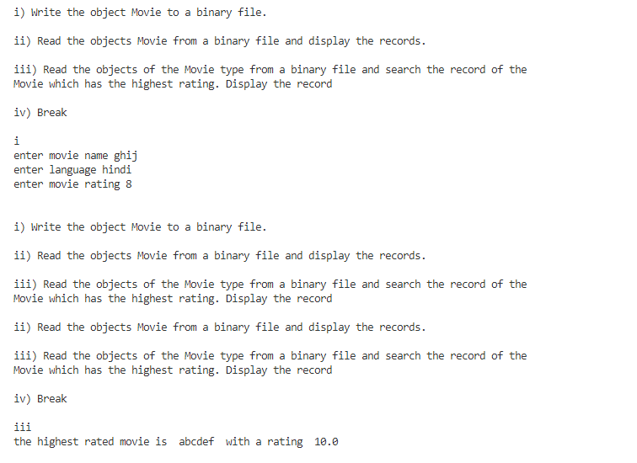

2)

AIM: Write a menu driven Python program to store and modify data related to products sold and their quantity and price in a binary file  
CODE:

"""PRANAV PRADEEP

ASSIGNMENT 3: Q 2: 4/6/24"""

import pickle

import os

def create_file():

    f = open("product.dat", "ab")

    f.close()

def store_data():

    f = open("product.dat", "ab")

    d = {}

    d["Pid"] = (input("enter product id "))

    d["Pname"] = (input("enter product name"))

    d["Qty"] = (int((input("enter quantity"))))

    d["Price"] = (int((input("enter price"))))

    pickle.dump(d,f)

    f.close()

def read_data():

    f = open("product.dat", "rb")

    try:

        while True:

            data = pickle.load(f)

            print(data)

    except EOFError:

        print("file read")

        f.close()

def search_data():

    f = open("product.dat", "rb")

    n = input("enter product name")

    while True:

        try:

            data = pickle.load(f)

            if data["Pname"] == n:

                print (data)

                break

        except EOFError:

            break

def update_data():

    f = open("product.dat", "rb")

    n = input("Enter name to update")

    try:

        while True:

            pos = f.tell()

            data = pickle.load(f)

            if data["Pname"] == n:

                print (data)

                data["Pid"] = input()

                data["Qty"] = int(input())

                data["Price"] = float(input())

                f.seek(pos)

                pickle.dump(data, f)

                break

    except EOFError:

        print("file not found")

    finally:

        f.close()

def delete():

    n = input("Enter Pid to be deleted")

    f = open("product.dat", "rb")

    fout = open("temp.dat", "wb")

    try:

        while True:

            data = pickle.load(f)

            if data["Pid"] != n:

                pickle.dump(data, fout)

    except:

        f.close()

        fout.close()

    finally:

        os.remove("product.dat")

        os.rename("temp.dat", "product.dat")

def move():

    n = input("Enter Pid to be moved")

    f = open("product.data", "rb")

    fout = open("temp.dat", "wb")

    try:

        while True:

            data = pickle.load(f)

            if data["Pid"] == n:

                pickle.dump(data, fout)

    except:

        f.close()

        fout.close()

create_file()

while True:

    a = input("""The menu options are:-

1) Add more data

2) Display All

3) Search for a product by name

4) Update the product price

5) Delete the product

6) Move certain products (by name) to a separate file: """)

    if a == "1":

        store_data()

    if a == "2":

        read_data()

    if a == "3":

        search_data()

    if a == "4":

        update_data()

    if a == "5":

        delete()

    if a == "6":

        move()

    if a == "7":

        break

SAMPLE OUTPUT:

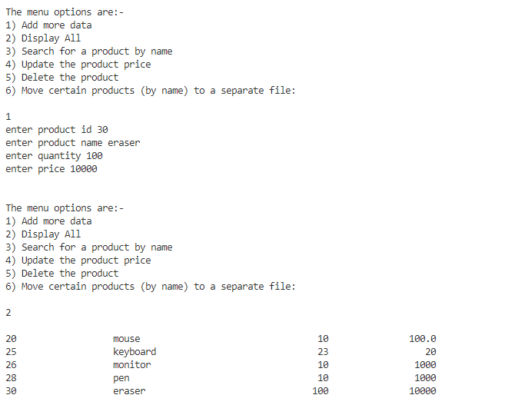

3)

AIM: Write a menu driven Python program to store and modify data related to employee information in a csv file(Emp.csv)  
CODE:

"""PRANAV PRADEEP

ASSIGNMENT 3: Q 3: 8/6/24"""

import csv

def create_file():

    f = open("Emp.csv", "a")

    f.close()

def store():

    f = open("Emp.csv", "a", newline = "")

    l = []

    l.append(input("Ename"))

    l.append(input("Eid"))

    l.append(int(input("Esal")))

    l.append(input("Department"))

    fout = csv.writer(f)

    fout.writerow(l)

def display():

    f = open("Emp.csv", "r", newline = "")

    fin = csv.reader(f)

    for i in fin:

        print ((f'{i[0]:20}{i[1]:20}{i[2]:20}{i[3]:20}'))

def search():

    f = open("Emp.csv", "r", newline = "")

    b = input("enter name")

    fin = csv.reader(f)

    for i in fin:

        if i[0] == b:

            print (i)

def search_dep():

    f = open("Emp.csv", "r", newline = "")

    b = input("enter department name")

    while True:

        a = csv.reader(f)

        for i in a:

            if i[3] == b:

                print (i)

def sort():

    f = open("Emp.csv", "r", newline = "")

    lo = []

    l = []

    while True:

        a = f.readline()

        if a:

            l = a.split(",")

            lo.append(l[2])

        else:

            break

    b = f.readlines()

    for i in range (len(lo)):

        for j in range ((len(lo))- i -1):

            if lo[j]>lo[j+1]:

                lo[j], lo[j+1] = lo[j+1], lo[j]

                b[j], b[j+1] = b[j+1], b[j]

    for i in b:

        print (i)

create_file()

while True:

    a = input('''

1) Add more rows

2) Display All

3) Search for a particular employee

4) Display the list of all employees working in a particular department given by user.

5) Sort the employee as per their salary and display.''')

    a = input("enter what you want to do ")

    if a == "1":

        store()

    if a == "2":

        display()

    if a == "3":

        search()

    if a == "4":

        search_dep()

    if a == "5":

        sort()

    if a == "6":

        break

4)

AIM: Write a menu driven Python program to store and modify data related to employee information in a csv file(Emp.csv)

CODE:

"""PRANAV PRADEEP

ASSIGNMENT 3: Q 2: 4/6/24"""

import csv

import os

def create_file():

    f = open("Travel.csv", "a", newline = "")

    f.close()

def store():

    f = open("Travel.csv", "a", newline = "")

    l = []

    l.append(input("Place_name"))

    l.append(input("Country"))

    l.append(int(input("TravelCost")))

    l.append(input("MiscCost"))

    fout = csv.writer(f)

    fout.writerow(l)

    f.close()

def display():

    f = open("Travel.csv", "r")

    fin = csv.reader(f)

    for i in fin:

        print (f'{i[0]:20}{i[1]:20}{i[2]:20}{i[3]:20}{"sum = ":5}{int(i[2])+int(i[3])}')

def delete():

    n = input("Enter place to be deleted ")

    f = open("Travel.csv", "r")

    f1 = open("temp.csv", "w", newline = "")

    fin = csv.reader(f)

    fout = csv.writer(f1)

    for i in fin:

        if i[0] != n:

            fout.writerow(i)

    f.close()

    f1.close()

    os.remove("Travel.csv")

    os.rename("temp.csv", "Travel.csv")

create_file()

while True:

    a = input('''

1) Add more rows

2) Display all the records

3) Delete a particular record

4) Break

''')

    a = input("enter what you want to do ")

    if a == "1":

        store()

    if a == "2":

        display()

    if a == "3":

        delete()

    if a == "4":

        break